**Covid-19 Classification using Deep learning In Chest Xrays**

**Project Goal:**

The aim of this project is to develop a fully automated tool Covid19 Classification in Chest Xrays

**Problem Statement:**

The huge increase in the number of COVID-19 patients is overwhelming healthcare systems around the world. With limited test kits, it is impossible to evaluate all patients with respiratory disease using conventional techniques (RT-PCR). The tests also have a long time and limited sensitivity. Detecting possible COVID-19 infections on chest X-rays can help isolate patients at risk while awaiting test results. X-ray machines are already available in most healthcare systems, and with most modern X-ray systems already digitized, there is also no transfer time for samples. In this work the chest radiographs to prioritize the selection of patients for subsequent RT-PCR tests. This could be useful in a hospital setting where current systems have a difficult time deciding whether to keep a patient in the room with other patients or isolate them in COVID-19 areas. It will also help identify patients with a high probability of COVID with false negative RT-PCR who need to repeat the test. In addition, the propose system use modern artificial intelligence techniques to detect COVID-19 patients using X-ray images in an automated way, especially in places where radiologists are not available, and to help make the proposed test technology scalable.

**Dataset Used**

1. Chest X-Rays in Patients with Pneumonia

<https://www.kaggle.com/paultimothymooney/chest-xray-pneumonia>

1. Covid19 X-Rays in Patients

<https://github.com/ieee8023/covid-chestxray-dataset/tree/master/images>

Download and save the covid19 and chest-xray-pneumonia dataset in the current folder.

**Experimental phase:**

**Requirements**

The main requirements are listed below

* Python 3.6.10
* PyTorch 0.3.0
* Torchvision 0.2.0
* Numpy
* Pillow 6.1
* Scikit-learn
* Pandas
* Seaborn
* Matplotlib
* Tqdm

**Experiment:**

**Prepare Data**

1. Prepare the COVID-19 dataset:

Randomly select a subset of patients for test and val sets.

* python data_tools/prepare_covid_data.py

Modify the file and rerun to update the train-val-test data split.

1. Prepare the combined dataset:

* python data_tools/prepare_data.py [--combine_pneumonia]
  + Class 0: Normal
  + Class 1: Bacterial Pneumonia
  + Class 2: Viral Pneumonia
  + Class 3: COVID-19

**Prepare pretrained-model**

The pretrained CheXNet model from in data folder. modify the network to classify among 4 classes, while keeping the convolutional layers same. Thus, initialize with CheXNet pretrained model weights and fine-tune on top of it.

* python tools/transfer.py [--combine_pneumonia]

**Training**

1. Train the classifier layer

First train the classifier layer, while freezing the weights of the convolutional layers to be the same as CheXNet.

* python tools/trainer.py --mode train --freeze --checkpoint models/CovidAID_transfered.pth.tar --bs 16 --save <PATH_TO_SAVE_MODELS_FOLDER> [--combine_pneumonia]

1. Fine tune the convolutional layers

Next, take the best model from previous step (according to loss), and fine tune the full model. Iincreasing the recall of COVID-19, specify the inc_recall option to 3

* python tools/trainer.py --mode train --checkpoint <PATH_TO_BEST_MOMDEL> --bs 8 --save <PATH_TO_SAVE_MODELS_FOLDER> [--combine_pneumonia]

**Evaluation**

Next, run the best model on the test set to see the results.

* python tools/trainer.py --mode test --checkpoint <PATH_TO_BEST_MODEL> --cm_path plots/cm_best --roc_path plots/roc_best [--combine_pneumonia]

**Inference with trained models**

Trained models are available in the models directory.

To run simple inference on a set of images, use:

* python tools/inference.py --img_dir <IMG_DIR> --checkpoint <BEST_MODEL_PTH> [--combine_pneumonia] [--visualize_dir <OUT_DIR>]

**Results:**

First results are for three classes. ROC curve and the confusion matrix as shown below

|  |  |  |  |
| --- | --- | --- | --- |
| **Class** | **AUROC** | **Sensitivity** | **PPV** |
| Normal Lung | 0.9795 | 0.744 | 0.989 |
| Bacterial Pneumonia | 0.9814 | 0.995 | 0.868 |
| COVID-19 | 0.9997 | 1.000 | 0.968 |

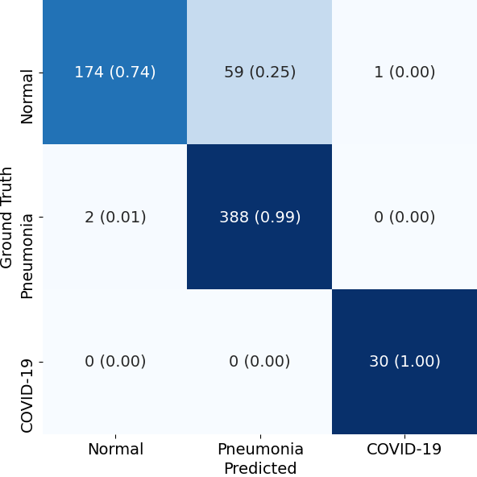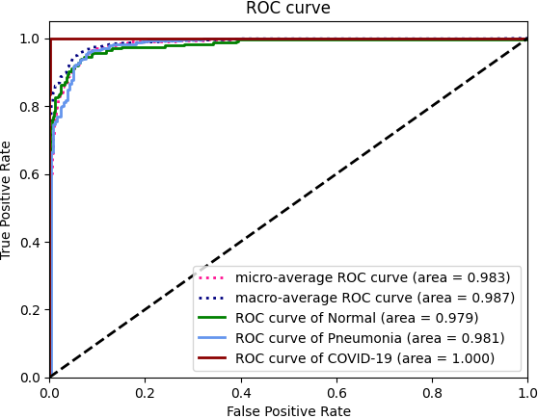

The Following results are for four classes. ROC curve and the confusion matrix as shown below

|  |  |  |  |
| --- | --- | --- | --- |
| **Class** | **AUROC** | **Sensitivity** | **PPV** |
| Normal Lung | 0.9788 | 0.761 | 0.989 |
| Bacterial Pneumonia | 0.9798 | 0.961 | 0.881 |
| Viral Pneumonia | 0.9370 | 0.872 | 0.721 |
| COVID-19 | 0.9994 | 1.000 | 0.938 |

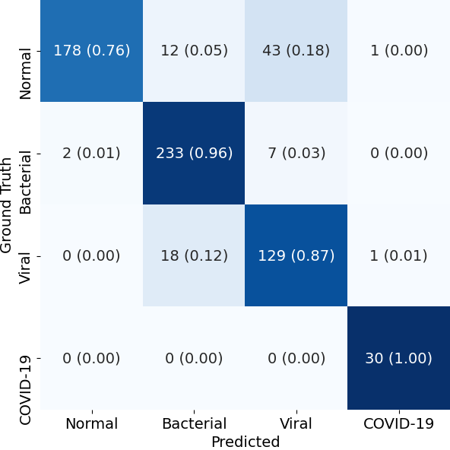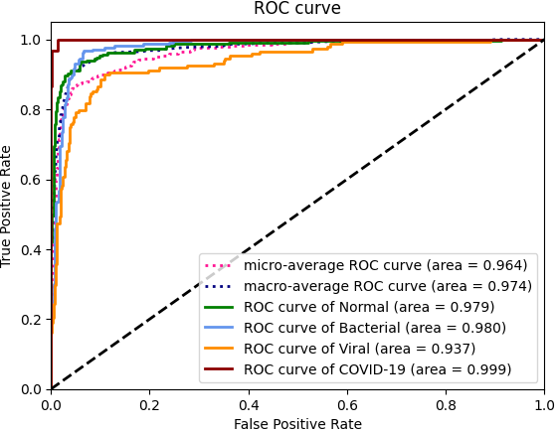

**Prediction on Test Dataset**

|  |  |
| --- | --- |
| **Input Image** | **Input Image** |
| **Inference Image** | **Inference Image** |